MultiPoint-WEB
Vision Document

Solution Summary
Every child around the world deserves a primary education, but many are not receiving a full primary education or even a partial primary education. This includes countries with low education systems and surprisingly many countries with highly rated education systems. They have many gaps where people still fail to obtain a full primary education. This is due to a lack of funding, training, materials, and manpower to provide a primary education.
Our solution is to build upon existing education systems and proved a set of low to no cost customizable web based learning activities that allow every child to participate with multiple mice on one computer, with limited available hardware resources and funding.
The web based solution allows for a growing repository of new lessons, courses, and activities to be shared around the world in multiple languages. When teachers create and share lessons, courses, and activities for their classroom in their local language, an increasing amount of materials will become available and more relevant to other classrooms around the world and allowing the system to adhere to a wider set of classrooms in need.
Our solution will provide maximum exposures by providing content through the web. The exposure though the web will provide additional access from students in a nontraditional setting such as students in rural areas or virtual class rooms. There will be many cases with no access to the internet. In this case the system will run locally (or local network) and work just as before, but will not receive updates of new content from around the world unless manually added.
The web based solution will be of little to no cost, by implementing a system that practically eliminates any required technical know-how to setup and use. The time and cost of producing classroom lesson material will be minimized by the availability of shared material created by other teachers around the world.
Our solution has a simple to use reporting systems to help monitor the progress of each student. In the case of a very high student to teacher ratio, this allows a single teacher to monitor a large set of students or even remote students in situations that otherwise would have been impossible.

User Scenario
How will a typical end-user (teacher or student) interact with your solution? Is this a collaborative or competitive solution and why?* (no limit)
A typical end-user that is a student will interact with our solution by playing educational games with groups of other students. First a student will enter the website or offline version and log in. Then each student will have their own mouse, and at the start of the games able to pick their own name. The games include competitive, parallel, and collaborative games. During a game, a student will be able to score points by choosing the right answers.
A teacher will also enter the web site or offline version and log in. They will have the ability to change and create games, add students, and view scores.
To change and create games, the teacher would just need to click edit on one of their own existing games, or search for one someone else’s. Here he or she could change the data about the game and the data in the games. The data in the games include the questions and answers. By clicking on a question box, they are able to change the data to any language. The same is true with an answer box. They also are able to change the activity played with the data. By clicking on change activity, the teacher is able to choose from a list of all available games.
The teacher is able to see who’s in his or her classroom and see there scores. By clicking on reports, there are a variety of types of data to look through. Each one of these lists, include a graph illustrating what data wants to be shown, from class scores in a single game to a timeline of scores for a specific student in a specific game. The teacher not only can see who is in his or her classroom, the teacher can also add or remove students too. To add a student, all the teacher has to do is click on the Students button, type the name into the textbox labeled name, and press the add button.
As mentioned above our product includes multiple games, of collaborative, competitive, and parallel games. Through our testing with students, we have learned that each one has its own benefits that help the end user learn the most effectively.
- Parallel games.

In these games when a player does something, it doesn’t effect what other players can do. In all reality the games would function the same with one player or five. But player can still compete, making an environment where people still stay interested and learn. A good example of this is Rat Race.

- Competitive games.

In these games peoples actions effect what other players can do. But to be successful, the players must do more then one click to finish a round. By adding multiple answers would help these games. Anything to help give every one a chance to find the right answer is helpful. It is also useful to have some aspect of the game make it longer to get a right answer. As in Monkey Lies, the answers are hidden; people can’t see all the answers at once. A Physics game could fit here too. By making people throw or move things, will slow down each player, giving everyone a chance to find a right answer.

- Collaborative games.

A collaborative game is any game where a player can’t chose an answer by them self. This will be successful in getting everyone involved. Players will also have to help each other learn as they need each other to win. A game idea could be a physics game where there are a pile of answers and a pile of questions. In order for a point to be scored, one player must grab a question and another must grab an answer.

Feature Set
This should explain all of the screens in your application and any UI element they contain. Be sure to explain specific usage of each of the elements of your application (1000 words max)

Login
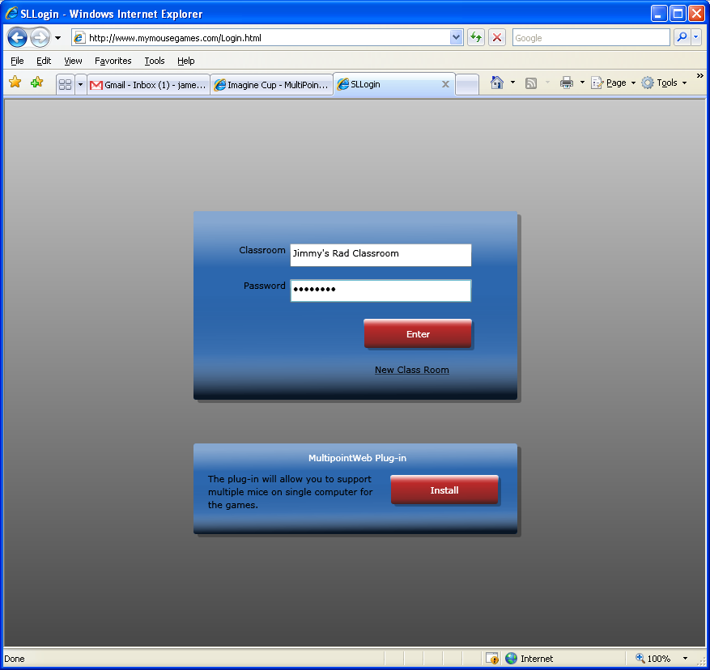
A simple login allows a teacher or student to login to the classroom. When the student logins in, the student will see a simple list of games to play. There is a common or shared password for the students. When the teacher logins in with his/her password, the teacher will see the dashboard that allow him/her to view and modify the classroom games and settings.

Play
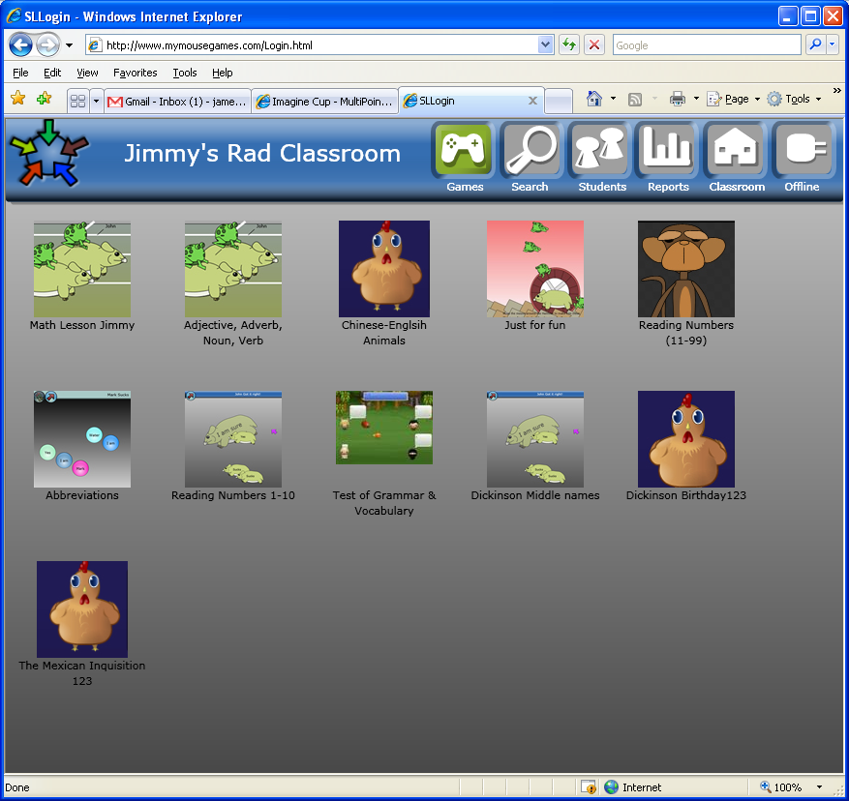Students can play the games that the teacher as set up for them in their classroom. After logging in, the student clicks on a game to play.
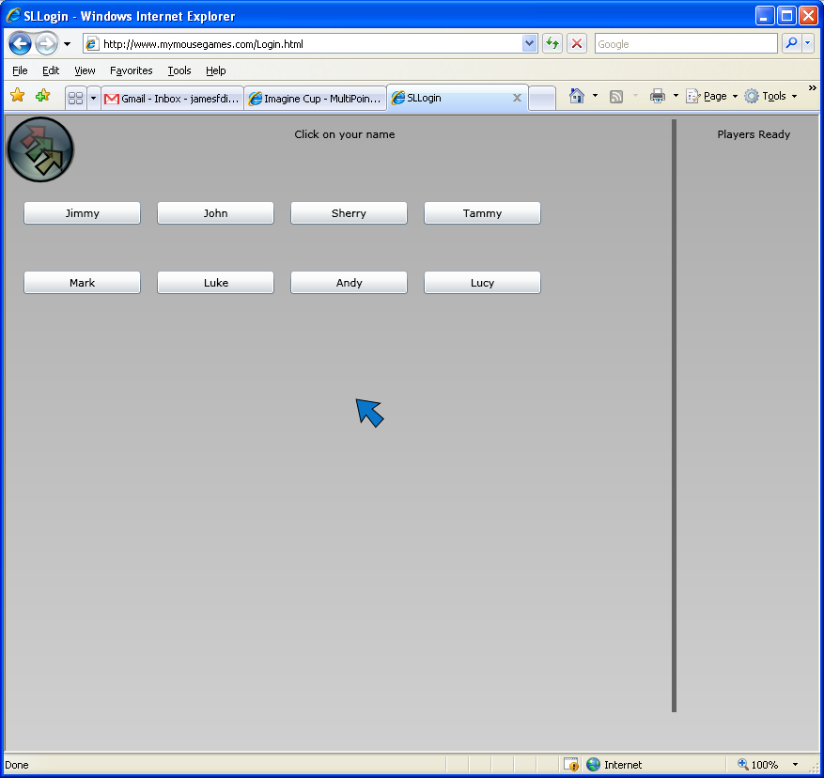
From there the student chooses his/her name. Every student will get a different random colored mouse for the game.
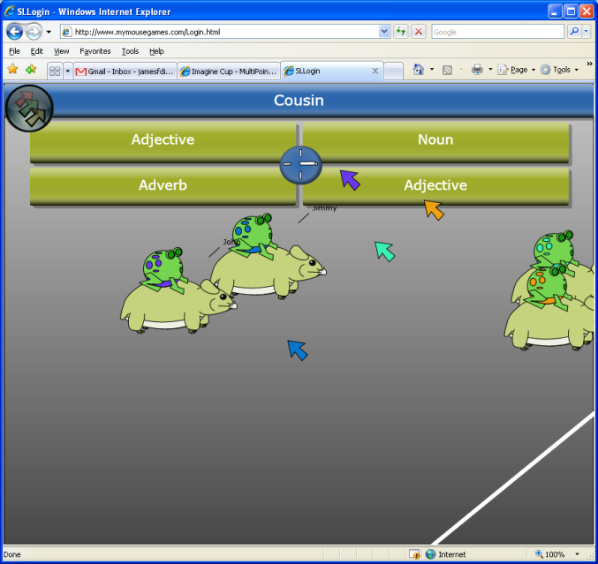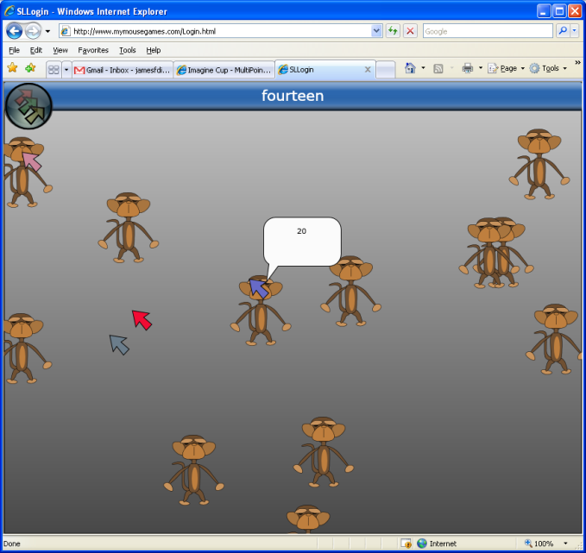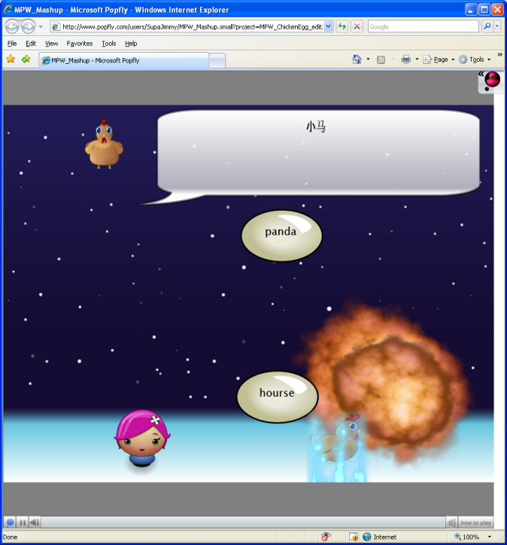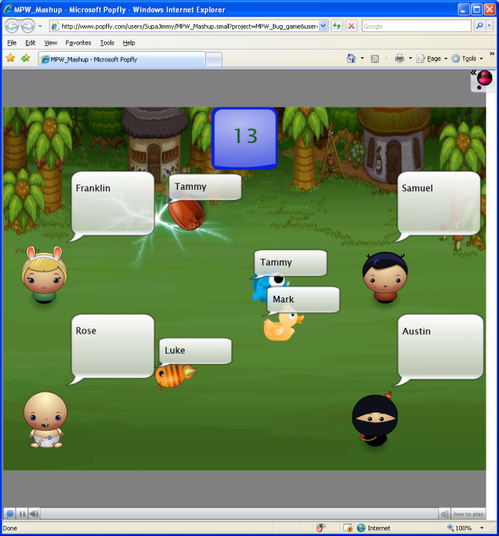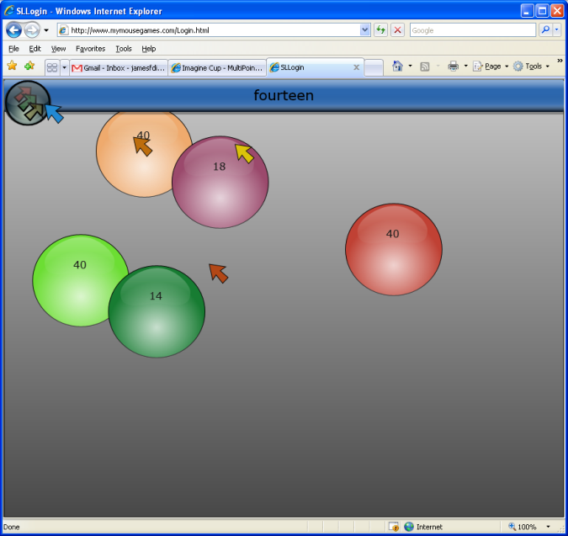

The games can be almost any type of game you can think of. Games consist of a lesson data and an activity that the teacher has setup (more details in the Create section).
Each game can be very different as the creator has great flexibility in creating them.
Every games reports back some sort of score for each student on an individual level.
Most games have two major common components; Positive feedback on a correct answer and negative feedback on an incorrect answer, as well as a final score at the end.

Create-Game
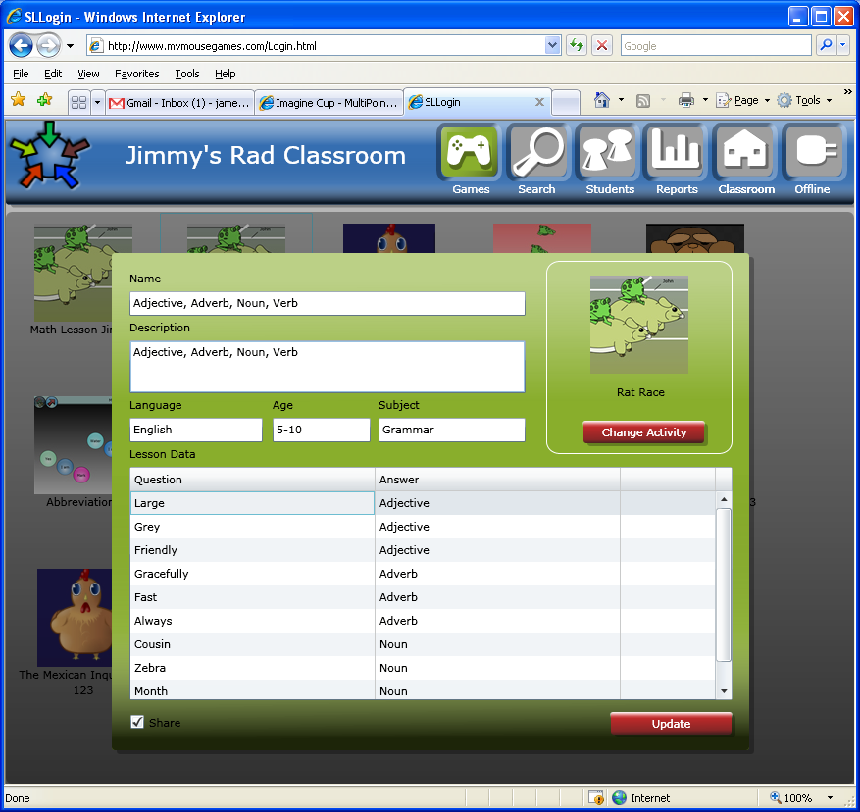
Games consist of a lesson data and an activity that the teacher has setup.
To edit a game, enter as a teacher and click “Edit” on the game.
The lesson data is a list of question and answers. These are text based and work in any language. Images are also allowed for a question or answer (images not yet complete). There are tags to identify the games such as: game name, description, subject, age group, language. These are very helpful in organizing and sharing the games (detail in sharing section). Games can also change their activity with a simple click and choose. Because any activity can be used with any set of lesson data, the possibility of possible games is endless.

Create-Activity
Activities are the interactive programs that use lesson data to create a game.
To edit the activity of a game, click edit game and click change activity. Activities can be change using one of three ways: simple, Popfly, and advanced.

Simple
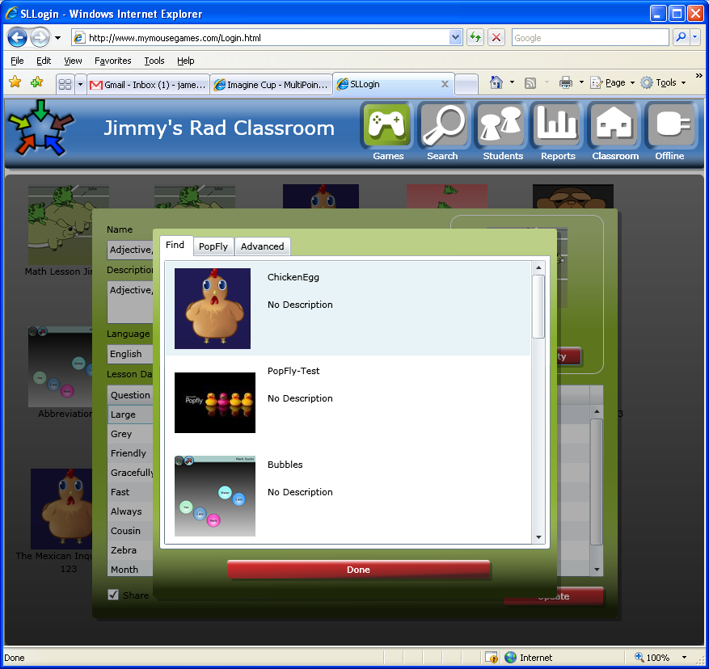
Just choose a pre-existing game from any other shared game.

Popfly
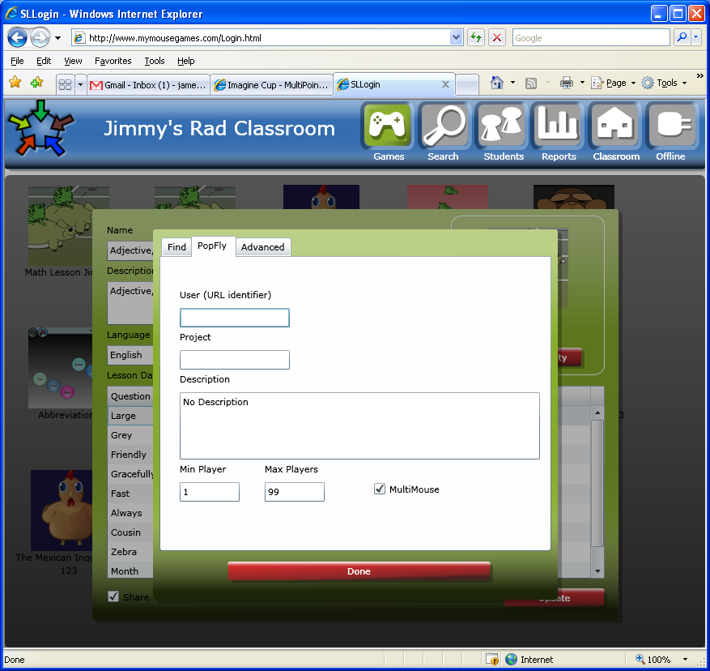
Popfly is a Microsoft site that allows you to create games without any previous programming knowledge.
Add a Popfly game by entering the owner name and game name.
You can also create a Popfly game. For that game to work with our solution just start your project by using one of our current Popfly games as a base. (Popfly game are currently not reporting scores)
*Popfly games do not support multi-mouse, only multi-students on a single keyboard

Advanced
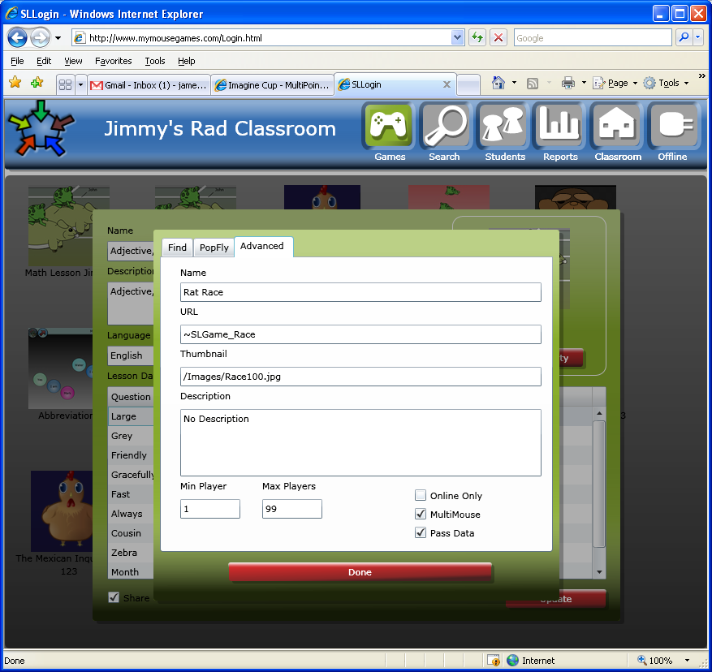
This is for the advanced user. Games a can be made in Silverlight/Flash/JavaScript. Advanced settings are here to allow a new game to be added.

Share/Find
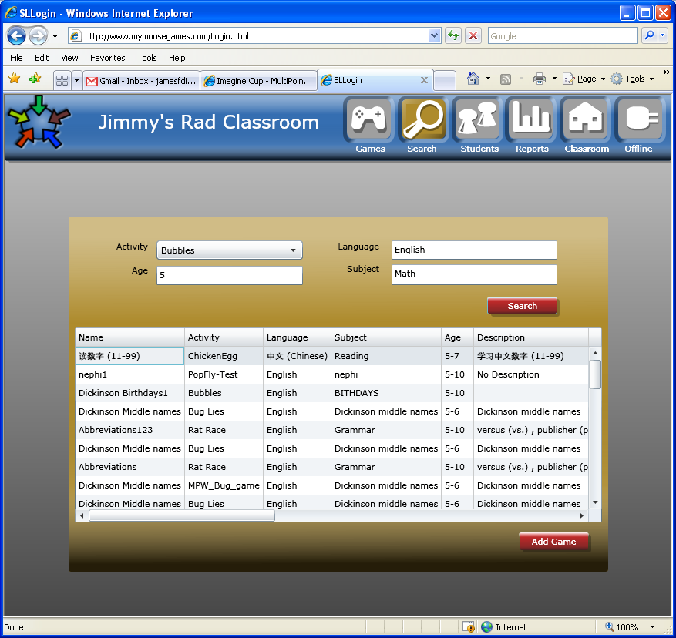
Every game can be shared. When you create a game, just leave the checkbox marked as shared (default).
Finding shared games is a simple as two clicks; click find, enter search, and click “Add”. Games can be searched by subject/language/activity/age. Once you add a game you can edit any and every part of the game, as it is a copy of the original.
The web based solution allows for a growing repository of new lessons, courses, and activities to be shared around the world in multiple languages. When teachers create and share lessons, courses, and activities for their classroom in their local language, an increasing amount of materials will become available and more relevant to other classrooms around the world and allowing the system to adhere to a wider set of classrooms in need.

Students
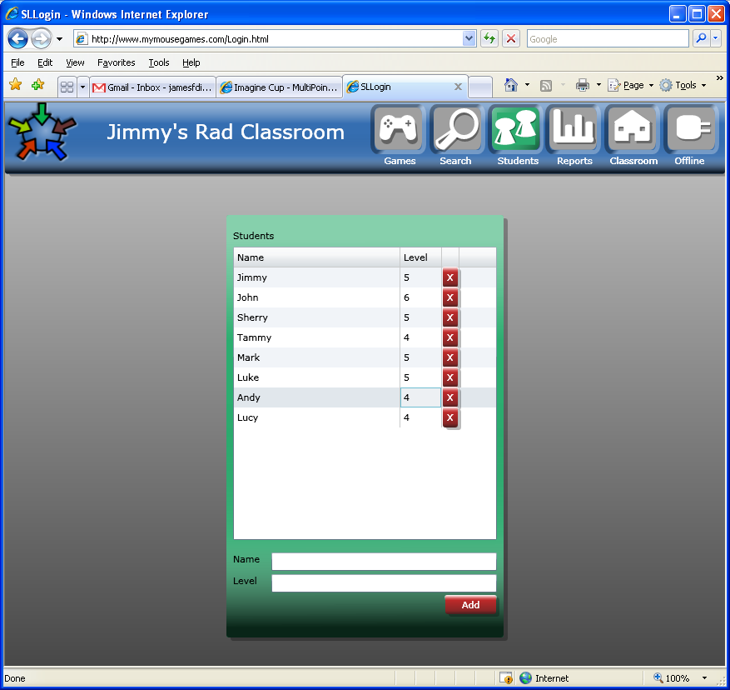
Enter student names by just adding them to the list. Also add their Level/grade (more explained in reporting)

Reporting
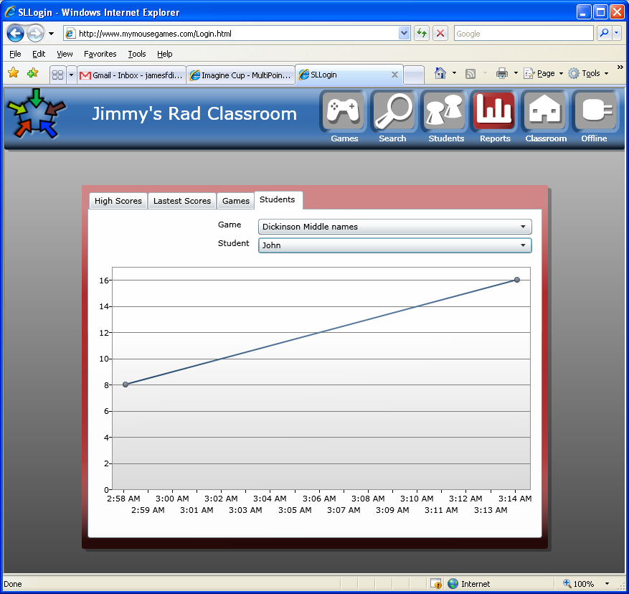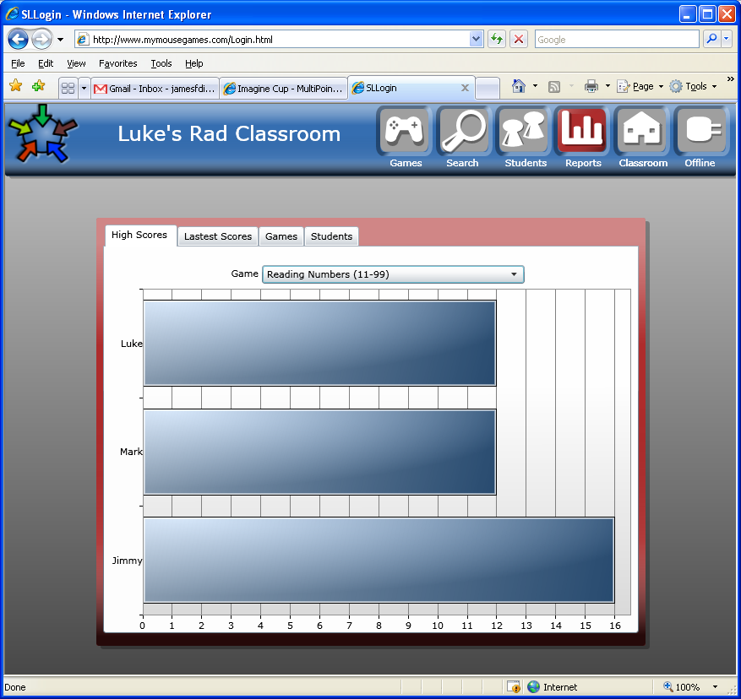
The reports display the high scores for a game in a classroom or a detailed view of a single student’s progress in a particular game over time.
The reports allows us to overcome heterogeneous learning groups by showing a report that compares the students’ scores with other students in the classroom in the same grade level even when they may have played a game with students above or below them. Each game will have its own scoring system. The score amount doesn’t matter as much as the comparison to other student do, as to indicate if the student is falling behind his grade level within the classroom. This helps the teacher to monitor the individual progress of students with different levels of education/grade using the same computer playing the same game at the same time.

Offline
Simply click the offline button. There is no install process other than a single “OK” click; you don’t even need admin rights as it lives in the internet sandbox. Once offline everything works as before, you can play and even modify the games. As soon as you connect to the internet again, all the new data is merged again online. You can even find shared games that have been cached from previous searches. If there is never an internet connection you can still share data by exporting* the data to a disk and importing it to another computer.

Plugin
The plug-in allows our web-based games to receive multi mouse input. The plug-in is installed through the ActiveX install or running the small install file by clicking the link.

Windows/Mac/Linux/IE/Firefox/Safari
Our solution is based on Silverlight and with that allows us to run our classroom and games on multiple operating systems (Windows/Mac/Linux) and multiple browsers (IE/Firefox/Safari). Currently our multipoint plug-in works for windows (XP/Vista) only, but could easy be created to support other operating systems.

Mobile
Silverlight has been announced to be released on cell phone in the near future. Since the classroom is Silverlight based, all games and classroom administrations will be available on mobile phones.
Currently games can be built for the mobile phone for a single mouse games using JavaScript. There is one game currently working on the mobile phone with is a simple quiz that pull custom lesson data and reports back to the classroom. The classroom teacher view is also exposed via html which allows teacher to modify their games (read only currently). Report could be exposed as well though html and thus to mobile.*

*Feature not fully implemented yet

Impact Assessment
How did you choose your success metrics and how did your solution perform against them? (500 words max)
We believe not only can we create a fun, easy way for multiple people to learn, but that the results of playing together will match if not beat individuals studying traditionally.
One example of a test study was when we went to a high school Spanish one class to test the effectiveness of our games compared to studying from paper. For the data, we picked the hardest words, the ones that sounded the least like English.
First everyone took a multiple choice pre-test, on 10 vocabulary words in their next chapter. When they finished the test, we took them and did not correct them. After they were done with the test we split up into 2 groups, a group studying individually from the book, outside, (the Control), and group playing the games (the Variable).
After ten minutes, both groups came back in and took a post test, similar to the pre-test.
Our results showed that the students in a group playing our games learned equally the same as students studying by themselves. We believe with more changes to our games got from feedback, we could reach past individuals learning on there own. Another observation we had showed that some students would hardly do anything on paper, or even nothing. The same students would play the games happily and learned from them.

Customer Feedback
How did you engage with students and/or teachers to refine your solution? (1000 words max)
To test and refine our product, we asked multiple groups if we could run a product in their classroom or meeting house with the students there. We met with a Spanish classroom, a daycare, and a scout group. At each of these places we found things that could be improved and got advice from the students and adults around. We also tried to do studies testing the effectiveness. One place we would like to elaborate on is our trip to Learning Village, a daycare.
We went to Learning Village, a day-care center, for our last test run. The group was not very enthused in taking tests when I asked them. But I believe I still got good feedback. Out of the group of kids, 3 kids came up and played our games. There was a 3rd grader, a 1st grader, and a pre-school student.
When I asked the 3rd grader what she thought about the games, he responded with they are fun. This must have been true because when I told them I had to go, they wanted to play more. I asked her if this was helping learn the answers. She said, “Yah I think so.” I asked one more question about her knowledge of Spanish. She told me that she didn’t really know any Spanish. She scored 100% on the post-test.
The 1st grader had a hard time reading, but that didn’t stop him. After the first round when the 3rd grader won, he was determined to win. For the first 3 times, he would hardly get anything right. By the time we were leaving, he was just behind the 3rd grader. I asked him if he would take a post-test, and he told me he didn’t want to do any school work. This proves to me even more the effectiveness of the games as they were interesting enough since he would play the games to learn even when he wouldn’t do other things to learn.
The pre-school student needed help most of the time. My sister, Heidi, came and helped him with the mouse and by reading him the questions and answers. This guy was the most surprising. By the end of day, he was actually getting a good portion of the answers right. The most surprising thing was when we turned on a physics game the kid caught on, and started using the mouse by himself.
In this test run, I did not have a control (a group to study from paper instead of the games.) The reason for this is I couldn’t get any one to study. I believe if they did they would have lost interest really fast, resulting in poor improvement, if at all. At the same time I had 3 kids play the games and they really enjoyed it. They didn’t want to quit. And the level of which they learned surprised me. The 3rd grader was getting all the right answers really quickly, after the 1st couple of rounds. She got 100% on her post test. The 1st grader, who had a hard time reading, was even improving fairly steady. He learned the most because of the competition. He was determined to beat the 3rd grader. The pre-school student had a hard time moving the mouse, but he still wanted to play. He was getting help from my sister Heidi, with the mouse and understanding the words on the screen. I don’t know exactly what all he learned, but I do know he learned papa, and a couple others. What impressed me the most was when Heidi was making a video; we had a physics game on the screen. The pre-school student learned how to use the mouse well enough by now to grab objects on the screen and throw them. For him, without the games, in comparison to paper studying, he would have learned nothing.
From what I saw, the kids learn much more from the games, and then they would have on paper.
While we were here, we learned ways our games helped kids learn and things that were hindering their learning. As Bubbles was not as popular as Rat Race because of at least one reason, only one player could get the right answer. This is a problem because the best player was getting it every time, and the other players lost interest. Another reason this is bad came from an interview with my Spanish teacher. She said if every one isn’t participating, the game is not going to be successful.
We have learned through our test runs that with a few important rules, games with multiple mice can be effective. In all games it is important to have a couple of features. First there needs to be a way for all players to be informed of the right answer at the end of a round. This should last for over 3 seconds. This will allow people to learn what the right answer is even they don’t find the right answer them self. Another important thing would be to show positive feedback when the right answer is chosen and negative feedback when the wrong answer is chosen. This will allow students to know if they have gotten the right answer. Wrong feedback could include disabling the mouse as this will help players to think about what they are doing. In other words don’t allow them to just click every thing.

Localization
How can your solution be localized to be used in classrooms across the world? (300 words max)
Every game contains lesson data. This lesson data can be customized to fit the needs of local situations. This also means the lessons can be in any language. The lessons consist of questions and answers and can be change with a simple click. The games do not care what the questions and answer is just that they go together.
Note: Some foreign font may not display on your computer if you do not have an installed font of that language on your computer. Most can be downloaded from the Microsoft site. In most cases you will have that font installed if you speak that language.
Pictures can also be used in place of text.

*Feature not fully implemented yet

